With each execution I would set the input varibles to the appropriate date type, String, int, or Double to run them through the process.

addUpp (3.2, 2.2) result Double, both vars are double.

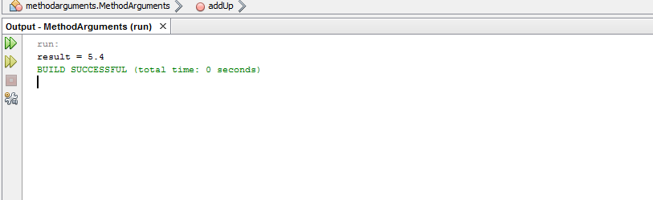

addUp (1, 4) result integer both vars are integers



addup(“2, 3.5) result Double mixed I believe because the double can accommodate an int var.



addUp (“one”, “Three”) result, string because both fields are strings.



addUp (1, “three”) would not compile because string field could not accommodate an int and Int could not accommodate a string.

